Distribution:
Mr K Croxton (Chair, MOG) | Ms V Hughes (PCC: Head of HR) | Mr B Roskell (PCC: Head of Stewardship)
Mr G Causer (Deanery Synod) | Mrs B Jeremy (Deanery Synod) | Mr D Squibb (PCC)
Mr N Collison (PCC: Head of Fabric) | Mr H Morten (PCC: Head of Finance) | Mrs P Stanton Saringer (Deanery Synod)
Mr M Evans (Churchwarden) | Mr A Miscampbell (PCC) | Staff Team
Mrs S Fox – (PCC Secretary) | Ms R Newell (Deanery Synod) | Notice Board
Mrs P Fox (PCC) | Mr A Pallett (PCC) | Parish Safeguarding Officers
Mr A Gibson (Deanery Synod) | Revd Will Pearson Gee (Rector and General Synod)
Mr J Grinyer (PCC) | Mrs L Piper (PCC)
Mr M Hailey (Churchwarden) | Revd K Pellereau (Curate)
Mr P Hirons (Diocesan & Deanery Synod) | Mr M Roskell (PCC: Head of Production)

MINUTES OF AN EXTRA PCC MEETING
Meeting of: Buckingham PCC
Date and Time: Saturday 18th March, 10am - 1pm at The Centre, Verney Close
Present:
Mr Gerry Causer (GC) | Revd Will Pearson Gee (WPG)
Mr Nigel Collison (NC) | Mrs Lorna Piper (LP)
Mr Mike Evans (ME) | Mr Brian Roskell (BR)
Mr Paul Hirons (PH) | Mr Andy Pallett (AP)
Mrs Vicky Hughes (VH) | Mrs Tracy Roskell (TR)
Dr Andrew Gibson (AG) | Mrs Pauline Stanton Saringer (PSS)
Mr Harry Morten (HM) | Ms Beth Jeremy
Mr Jacob Wigley | Mrs Jo Wigley

Item |  |  | Action
1 | Opening Prayer & Bible Study  The meeting opened with a bible study & prayer led by WPG
2 | Apologies for Absence  Apologies were received from Max Hailey, Ruth Newell, Mike Roskell, Andrew Miscampbell and David Squibb
3 | WPG outlined what the situation was in the CofE (see briefing below) following the vote at General Synod and explained why in his opinion we were in a very dangerous situation with our bishops departing from the historic teaching of the Church on matters of human sexuality. He outlined why he believed we should join the Oxford Good Stewards Trust so that if the time came there would be a formal mechanism by which our parish share could be diverted to a better cause than a liberal and revisionist Diocese.  There was a long and lively debate with some agreeing that action needed to be taken and others feeling that a failure to pay 100% of our share was unethical.  It was agreed that the discussion would continue and that a rep from the OGST would be invited to speak to the PCC at a forthcoming meeting.  The motion: “This PCC agrees to continue a discussion on joining the OGST” was proposed by AP and seconded by JW. The motion passed nem con.
4 | A discussion was held regarding the appointment of an associate minister (AM).  An AM would be a part of the SLT  Share in preaching and taking services  Head the Discipleship Department including:  - Responsibility for connect groups  - Connect group training and resourcing  - Delivering discipleship training programmes  - Alpha  - Prayer Ministry  Line-managing the CYPFam department  Responsibility for operations?  Potentially be part of succession planning  Could be P/T – progression to F/T  Could live in own house  Ideal is to have a house tied to the post  Could live in curate’s house but therefore no curate and may put off someone expecting an incumbent-level house  It was agreed that due to financial constraints this aspiration would have to wait.  The motion: “This PCC is committed to realising an aspiration to appoint an AM not before 2026” was proposed by LP and seconded by BJ. The motion was passed nem con.
5 | The meeting ended with The Grace at 12.30pm

RECTOR’S PRESENTATION TO THE BPC PCC ON THE SITUATION FOLLOWING THE GENERAL SYNOD VOTE ON ‘PRAYERS FOR LIVING IN LOVE AND FAITH’
SATURDAY 18TH MARCH 2023
It is perfectly understandable that most of us would like to be able to focus our attention this morning on the task of growing the Church, and also addressing the many pressing challenges facing our community but the reality is that we cannot avoid the issues arising from Living in Love and Faith, following the debate at General Synod last month.
This is a complex and contentious topic and what I want do now is to sketch out some of my thinking on where we have got to, and then look at one way in which we might choose to respond – by joining the OGST.
I hope too that we will remember today that these issues are about some of the deepest and most personal aspects of people’s lives, and centre on some of our deepest convictions. It behoves us to speak carefully, compassionately and with graciousness and respect towards one another.
Let me wind back a little. The LLF process has been underway for almost six years. We have been committed to the process throughout. It has involved large numbers of people, with different life experiences and from a wide range of church traditions, seeking to understand one another’s perspectives and to explore these more deeply both theologically and in other ways. This first phase was followed by a process of discernment by the College of Bishops, leading to a set of draft proposals from the House of Bishops being presented to and debated at General Synod last month.
At the same time, various pronouncements were made by some bishops and others which put a particular spin on the proposals and sometimes suggested that they were anyway only a staging post towards further and more radical change.
As a result of this, and in line with what I have said previously and publicly about my own convictions, I affirmed in church our belief in the Church of England’s traditional doctrine of marriage as a life-long union between a man and a woman.
The prayers do include some perfectly acceptable ones such as those that affirm and bless companionship, affection and mutual love and support, in other forms of relationships, including between people of the same sex, and ‘m sure we support finding ways of affirming and celebrating these.
The motion proposing the prayers was carried with potentially serious consequences for the mission and unity of the Church of England and for the Anglican Communion.
The Global South – a huge chuck of the communion has already said that they can no longer look to the CofE as the mother church.
We in the west have ridden rough shod, in a sort of colonialism, over the views of 75% of our communion. whilst we represent only a fraction of the communion and we have done this to appease between 1.6 and 3.3% of the population.
The full motion, as amended, was as follows: That this Synod, recognising the commitment to learning and deep listening to God and to each other of the Living in Love and Faith process, and desiring with God’s help to journey together while acknowledging the different deeply held convictions within the Church:
(a) lament and repent of the failure of the Church to be welcoming to LGBTQI+ people and the harm that LGBTQI+ people have experienced and continue to experience in the life of the Church;
(b) recommit to our shared witness to God’s love for and acceptance of every person by continuing to embed the Pastoral Principles in our life together locally and nationally;
(c) commend the continued learning together enabled by the Living in Love and Faith process and resources in relation to identity, sexuality, relationships and marriage;
(d) welcome the decision of the House of Bishops to replace Issues in Human Sexuality with new pastoral guidance;
(e) welcome the response from the College of Bishops and look forward to the House of Bishops further refining, commending and issuing the Prayers of Love and Faith described in GS 2289 and its Annexes;
(f) invite the House of Bishops to monitor the Church’s use of and response to the Prayers of Love and Faith, once they have been commended and published, and to report back to Synod in five years’ time;
(g) endorse the decision of the College and House of Bishops not to propose any change to the doctrine of marriage, and their intention that the final version of the Prayers of Love and Faith should not be contrary to or indicative of a departure from the doctrine of the Church of England.’
The Votes on the motion were as follows:
Bishops 36 for, 4 against, 2 abstained Clergy 111 for, 85 against, 3 abstained Laity 103 for, 92 against, 5 abstained
You will see from this that the votes in the Houses of Clergy and Laity were fairly close – as they had been with many of the other amendments, all of which were lost.
clause (g), (g) endorse the decision of the College and House of Bishops not to propose any change to the doctrine of marriage, and their intention that the final version of the Prayers of Love and Faith should not be contrary to or indicative of a departure from the doctrine of the Church of England.’
was opposed by the liberals because it restates that there was to be no change in the Church of England’s doctrine of marriage.
But what has become clear is that the proposals as they stand leave the Church of England deeply divided.
The reality is that the proposals as they stand do not command sufficient widespread support to enable the Church to move forward together.
I am deeply conscious of the responsibility of my role as your Rector to do what our bishops have shown themselves incapable of doing: to uphold the historic teaching of the Church ensuring that the historic teaching of the Church of England, about marriage as a lifelong union between a man and a woman and as the intended context for sexual relations, is upheld.
this is what the church catholic has always believed
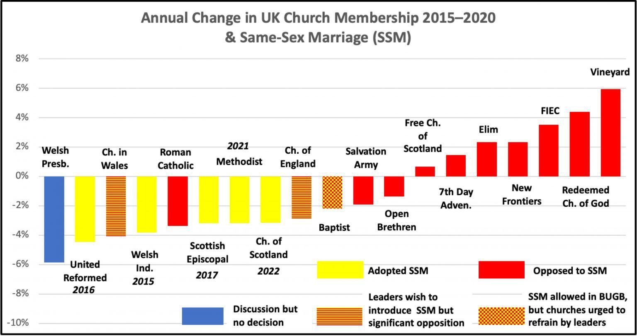
You will note from this bar chart that all the denominations that have embraced same sex blessings/marriage are dying and those that have not are growing.
There is a great deal more to be said and done about the content of the prayers as yet to be commended by the House of Bishops, as well as about legal issues regarding the status of the prayers and the position of clergy who choose either to use or not to use any such prayers.
These are all serious issues that are far from resolved. Depending on how these questions are answered, consideration will also need to be given as to how we accommodate differences of conviction and practice within the Church of England.
I want to make it clear that I am deeply torn by these issues. I recognise that what I have said may well be a huge disappointment (or worse) for many of our sisters and brothers in the LGBTQIA+ communities and their supporters, and I am deeply sorry for the pain this will cause.
My profoundest instinct as a pastor is to seek for a way forward that could be embraced by all.
However, the divided nature of the votes at General Synod, together with the reactions of people with very diverse convictions about these issues, have led me to believe that this is simply not possible. There are fundamentally different conceptions amongst us of what God requires of his people in terms of how we live out our relationships and our sexuality.

You either take scripture seriously or you do not.
In the end, each of us has to make a choice about our own understanding of these hugely important and deeply personal issues.
As your Rector, I am having to make a choice on where I stand, painful though that is.
Most famous of all Luther’s quotable words are those from the Diet (Assembly) of Worms (1521).
Commanded to repudiate his writings, he stood alone with his conscience against an array of powerful clergy and statesmen.

The official transcript quotes him as saying, “Unless I am convicted by Scripture and plain reason (I do not accept the authority of popes and councils because they have contradicted each other), my conscience is captive to the Word of God. I cannot and will not recant anything, for to go against conscience is neither right nor safe. Here I stand, I can do no other So help me God. Amen.”

And a prophetic scripture:

2 Tim 4
3 For the time will come when people will not put up with sound doctrine. Instead, to suit their own desires, they will gather around them a great number of teachers to say what their itching ears want to hear. 4 They will turn their ears away from the truth and turn aside to myths.

Scripture commands us to disassociate from false teachers – this is why our relationship with our bishops is now impaired.

Matthew 7
True and False Prophets15 “Watch out for false prophets. They come to you in sheep’s clothing, but inwardly they are ferocious wolves. 16 By their fruit you will recognize them

Romans 16
17 I urge you, brothers and sisters, to watch out for those who cause divisions and put obstacles in your way that are contrary to the teaching you have learned. Keep away from them. 18 For such people are not serving our Lord Christ, but their own appetites. By smooth talk and flattery they deceive the minds of naive people.

Acts 20
28 Keep watch over yourselves and all the flock of which the Holy Spirit has made you overseers. Be shepherds of the church of God, which he bought with his own blood. 29 I know that after I leave, savage wolves will come in among you and will not spare the flock. 30 Even from your own number men will arise and distort the truth in order to draw away disciples after them.

Ephesians 5
6 Let no one deceive you with empty words, for because of such things God’s wrath comes on those who are disobedient. 7 Therefore do not be partners with them

1 Timothy 1
3 As I urged you when I went into Macedonia, stay there in Ephesus so that you may command certain people not to teach false doctrines any longer 4 or to devote themselves to myths and endless genealogies. Such things promote controversial speculations rather than advancing God’s work—which is by faith.5 The goal of this command is love, which comes from a pure heart and a good conscience and a sincere faith. 6 Some have departed from these and have turned to meaningless talk. 7 They want to be teachers of the law, but they do not know what they are talking about or what they so confidently affirm.8 We know that the law is good if one uses it properly. 9 We also know that the law is made not for the righteous but for lawbreakers and rebels, the ungodly and sinful, the unholy and irreligious, for those who kill their fathers or mothers, for murderers, 10 for the sexually immoral, for those practicing homosexuality, for slave traders and liars and perjurers—and for whatever else is contrary to the sound doctrine 11 that conforms to the gospel concerning the glory of the blessed God, which he entrusted to me

2 John
8 Watch out that you do not lose what we have worked for, but that you may be rewarded fully. 9 Anyone who runs ahead and does not continue in the teaching of Christ does not have God; whoever continues in the teaching has both the Father and the Son. 10 If anyone comes to you and does not bring this teaching, do not take them into your house or welcome them. 11 Anyone who welcomes them shares in their wicked work

Jude
17 But, dear friends, remember what the apostles of our Lord Jesus Christ foretold. 18 They said to you, “In the last times there will be scoffers who will follow their own ungodly desires.” 19 These are the people who divide you, who follow mere natural instincts and do not have the Spirit

“A religion that gives nothing, costs nothing and suffers nothing, is worth nothing.” - Martin Luther.

